EXPERIMENT NO. 3
DEVICE ONBOARDING AND DATA FLOW IN AWS IOT CORE (GOOGLE COLAB SIMULATION)

Scenario: Smart Parking System
This simulates AWS IoT Core because an actual AWS IoT Core implementation requires an AWS account, IoT certificates, and cloud resources that cannot be reproduced in a standalone Colab notebook.
Aim
To simulate device onboarding and cloud data flow similar to AWS IoT Core using Python in Google Colab.
Objectives
- Simulate IoT device registration
- Authenticate devices
- Generate real-time parking occupancy data
- Send telemetry to the cloud
- Perform stream analytics
- Detect parking congestion
- Store cloud data
Software required
- Google Colab
- Python 3
- pandas
- numpy
- matplotlib
Theory
AWS IoT Core connects IoT devices securely with cloud services.
In this experiment, Google Colab simulates:
- Device Registration
- Device Authentication
- Cloud Upload
- Cloud Analytics

Algorithm
- Start Program
- Register IoT Device
- Authenticate Device
- Generate Parking Occupancy
- Send Data to Cloud
- Calculate Mean Occupancy
- Detect Congestion
- Plot Live Graph
- Save CSV
- Stop
Google colab code
import random
import pandas as pd
import matplotlib.pyplot as plt
num_slots = 100
slot_number = []
status = []
vacant_slots = []
occupied_slots = []
for i in range(1, num_slots + 1):
# 70% Occupied, 30% Vacant
if random.random() < 0.7:
s = "Occupied"
occupied_slots.append(i)
else:
s = "Vacant"
vacant_slots.append(i)
slot_number.append(i)
status.append(s)
# Create DataFrame
df = pd.DataFrame({
"Parking Slot": slot_number,
"Status": status
})
print(df)
print("\n========== PARKING SUMMARY ==========")
print("Total Slots :", num_slots)
print("Occupied Slots :", len(occupied_slots))
print("Vacant Slots :", len(vacant_slots))
print("\nVacant Slot Numbers:")
print(vacant_slots)
print("\nOccupied Slot Numbers:")
print(occupied_slots)
if len(occupied_slots) > 85:
print("\nParking Status : HIGH TRAFFIC")
else:
print("\nParking Status : NORMAL")
# Save CSV
df.to_csv("parking_slots.csv", index=False)
# Plot
plt.figure(figsize=(14,4))
colors = ['red' if x=="Occupied" else 'green' for x in status]
plt.bar(slot_number, [1]*num_slots, color=colors)
plt.xlabel("Parking Slot Number")
plt.title("Smart Parking Occupancy")
plt.yticks([])
plt.show()
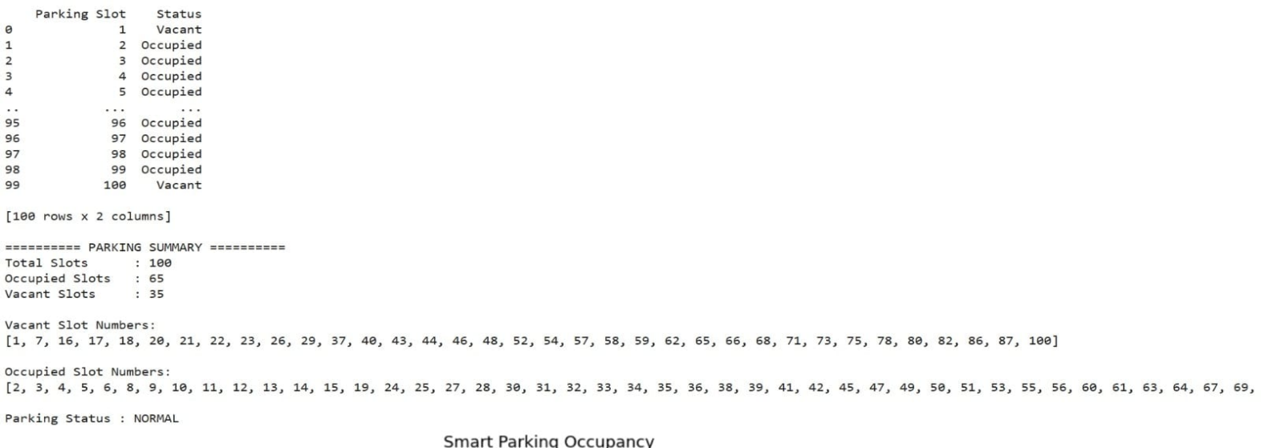
Output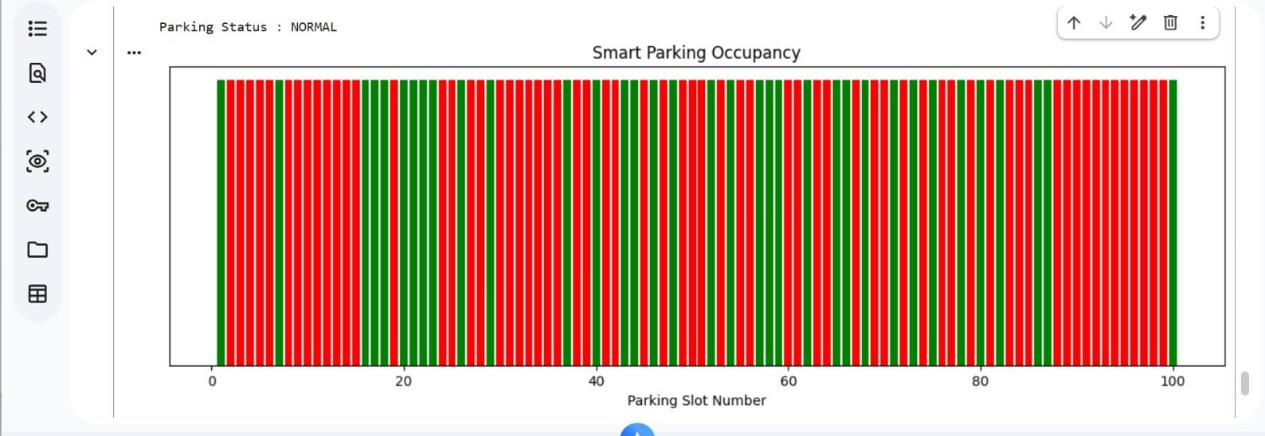
Result
The Smart Parking IoT device was successfully onboarded, authenticated, and transmitted parking occupancy data to the simulated cloud environment. Stream analytics were performed, congestion conditions were detected, live graphs were displayed, and the collected data was stored successfully for future analysis.

